**Final Review**

**QUIZ 1**

a) <https://math.stackexchange.com/questions/517151/can-somebody-explain-to-me-cantors-diagonalization-argument>  
b)  
**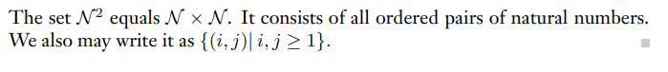  
**  
c)  
d)A problem where you ask someone to write a program that will output the largest number with the least amount of characters of code.  
e)  
 **QUIZ 2**

a) <https://www.geeksforgeeks.org/difference-between-dfa-and-nfa/#:~:text=DFA%20can%20be%20understood%20as,have%20many%20possible%20next%20states>.

**NFA-** nondeterministically chooses next state, each state can have multiple possible next states, can have multiple possible paths that result from reading a given word  
**DFA-** deterministically chooses next state, each state only has one next distinct state, always has one possible path a given word can follow to an accepting state  
NOTE: every DFA is NFA but not vice versa; there exists a DFA for every NFA  
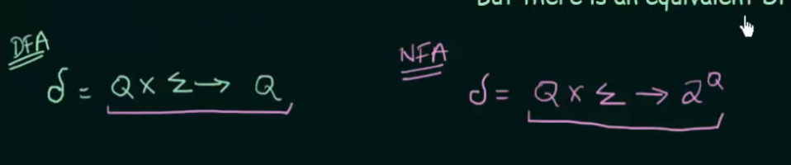  
q can be in 2^q but 2^q cant be in q  
b) a(aUbUc)*(bcUcc)  
**  
d)** [**https://www.youtube.com/watch?v=Rz3AGScgtMs**](https://www.youtube.com/watch?v=Rz3AGScgtMs)

**d  
f)** [**https://www.youtube.com/watch?v=yewZdv-QaLE**](https://www.youtube.com/watch?v=yewZdv-QaLE)

**QUIZ 3**

**  
a)** A TM is a turing machine which determines states in a deterministic way meaning that there is always a certain path a machine must follow when reading a certain input string; a ntm on the other hand guesses or nondeterministically chooses next state as there can be more than one action for a given situation in the turing machine. **b)  
c)** we can prove that every regular language is turing decidable by constructing a TM T which simulates a DFA D for any given regular language. The states in T will be similar to D’s states and we know that a DFA must always halt. Once the end of the input is reached if T corresponds to a final state in D, T will halt and accept; otherwise, T will half and reject.**Text, letter
d)** Algorithm: <https://stackoverflow.com/questions/50338357/a-turing-machine-that-decides-02n-n0-thats-not-the-commonly-accepted-one>  
**e)  
f)  
To show L is Turing Decidable we must show that there exists a TM which accepts strings in L and rejects strings not in L**If LL is Turing recognizable, there exists a TM M1M1 that halts and accepts any input string w∈Lw∈L. It is not guaranteed to halt on any input string w∉Lw∉L.

If L¯L¯ is Turing recognizable, there exists a TM M2M2 that halts and accepts any input string w∉Lw∉L. Similarly to above, M2M2 is not guaranteed to halt on any input string w∈Lw∈L.

Now, for every ww we have two options: either w∈Lw∈L or w∉Lw∉L. Therefore for any input string ww, exactly one of these machines will halt and accept. This allows us to construct the decider described in you proof. Create a machine MM that simulates M1M1 and M2M2. With ww as input, accept ww if M1M1 accepts, reject if M2M2 accepts. This machine is a decider for LL and therefore LL is decidable.

To prove L¯L¯ decidable as well, you could apply the same logic, but it is sufficient to point out that decidable languages are closed under complement.

**

**HW1**

**HW2**

**  
**

**HW3**

**  
**

**HW4**

**Idk any problems here that would show up on exam**

**HW5**

****